Curriculum vitae
Aistė Ščiukaitytė (Aiste Sciukaityte)

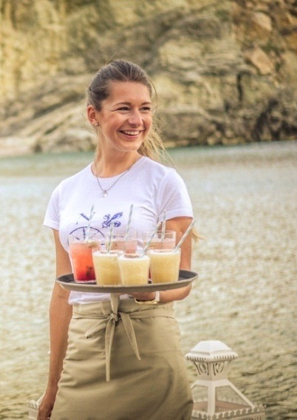

- Personal information:

Date of birth: 22/03/1992
Place of birth: Vilnius, Lithuania
Nationality: lithuanian
Home address: Filaretu street 17-2,
Vilnius, Lithuania LT-01207
Phone number: +37064013162
E-mail: aiste.sciukaityte@gmail.com
Skype: aiste.sciukaityte

- About me:

I am nearly 25 year old student from Lithuania. I am smiley, positive and happy person with firm character. My life and work experience has taught me that I am hard worker, responsible, attentive, thorough person and I always find energy to do my work good and until the end.
List of my previous works consists of several jobs only for 5-6 months. I used to go to work abroad for summer season and those places do not offer all year long jobs. I enjoy myself very much working at different countries and places. Every time is brand new experience that helps me to improve my professional and language skills. I had pleasure to work with and serve to people from all over the world and that is very interesting experience that I use every day in my life and work. Mostly I worked as a waitress at restaurants and bars, but I am always opened for new things. In my work experience list I did not mention working as a sales woman at designer clothes boutique, waitress at old rock bar, barman`s assistant at a pool bar and nanny at children`s garden. These jobs were recent but non- persistant.
I like being creative, sometimes I write, some other times I keep myself busy with interior design or fashion. I love nature and enjoy it very often doing climbing, cycling, swimming, walking, jogging. Another passion is dancing, I tried several types of this art and now I like keeping myself active.

- Education:

1999- 2008: primary school and middle school
2008- 2011: high scool
2013- now- International school of law and business (Vilnius, Lithuania). Department- Tourism and Hotel Management (not finished)

- Languages:
- Lithuanian- mother tongue
- English- very good
- German- good
- Greek- basic

- Work experience:
2016 December -2017 „The Capra“ hotel (5 stars). Saas Fee, Switzerland
Position- waitress
Duty: work during breakfast, lunch or dinner shifts. Prepare restaurant, bar area, take care of customers, make orders, serve food and drink items, make bills and money operations, make room service. Work with Micros program.
Comments: Luxury boutique 5 stars hotel, „La Locanda“ restaurant with two Michelin-starred chef.
Internet address: http://www.capra.ch/

2016 May- October „Ktima Lindos“ restaurant/ wedding Venue. Rhodes Island, Greece
Position- waitress
Duty: to prepare restaurant, present our new restaurant for customers and show them around, take orders, serve food and drink tems, make bills and money operations, prepare and serve at weddings.
Comments: New luxury restaurant/ wedding venue. Per season were served 28 weddings.
Internet address: http://www.ktimalindos.com/index/

2016 January- May „Domus Maria“ hotel (3 stars). Vilnius, Lithuania
Position- waitress
Duty: to prepare breakfast buffet, take care of customers and buffet during breakfast. Prepare and serve at pre-booked events.
Internet address: http://domusmaria.com/

2013-2015 „Lindian Jewel“ hotel and villas (3 stars). Rhodes island, Greece.
Position- waitress
Duty: to prepare restaurant and tables for dinner, manage service with „dinner included“ package, take orders and serve to „a la carte“ customers, make aperitives, make bills and money operations, prepare and serve at weddings.
Comments: Only summer season job; 2 seasons work at „Rotonda“ restaurant, one season work at „Azzurro beach bar“; restaurant has a Wedding Venue, average per season were served 45 weddings.
Internet address: http://www.lindianjewel.com/

2014 February- May Professional Practice at “Hotel Tilto” (3 stars). Vilnius, Lithuania
Comments: work at three different departments: Reception, Food and Beverage, Housekeeping
Duration: 3 months
Internet address: http://www.hoteltilto.com/

2012 May- October “Sani Asterias Suites” hotel (5 stars). Halkidiki, Greece
Position- waitress
Duty: prepare restaurant for dinner service, take orders, serve food and drink items.
Comments: Luxury boutique 5 stars hotel, “Water restaurant” with two Michelin-starred chef.
During season I was selected to a team and went on a work trip to Folegandros (greek) Island to prepare and serve at wedding.
Internet address: http://www.sani-resort.com/en_GB/our-hotels/sani-asterias-suites

2011 May- September “Kompanija” restaurant. Vilnius, Lithuania
Position- waitress
Duty: work morning, lunch or dinner shifts, take orders, serve food and drink items, make bills and money operations, prepare and serve at pre-booked events.
Internet address: http://www.kompanijajums.lt

- Other skills:
I have german language diploma “Deutsches Sprachdiplom”,
I have driver`s license

- Cover letter:

First of all Thank You for reading my resume and considering my candidature to work at you company. In case of a need for a worker for summer season 2017, I am interested to become part of Your team. I have few years international job experience working in Greece, Switzerland and Lithuania. I am used to work good, concentrated and in fast-paced environment. I am polite, smiley, friendly person, that is why I would be right person to represent your company. I am responsible and hard worker, this way you can be sure that my job is done and my tasks are always completed. I am learning fast and adjusting easily in new team and working place. Punctuality, responsibility, fast orientation and ambition for a good result are main points of my character and I would be glad to prove it for you.
Thank you again for considering me for job position, for any further information or conversation you are welcome to contact me by e-mail (aiste.sciukaityte@gmail.com) or mobile phone (+37064013162). I hope to hear from you soon.

Respectfully,

Aistė Ščiukaitytė

